CHEMICAL ENGINEERING TRANSACTIONS  VOL. , 2023 | A publication of
The Italian Association
of Chemical Engineering
Online at www.cetjournal.it

Guest Editors: Leonardo Tognotti, Rubens Maciel Filho, Viatcheslav Kafarov
Copyright © 2024, AIDIC Servizi S.r.l.
ISBN 979-12-81206-10-1; ISSN 2283-9216

Study of Niobium as a Catalyst for Conversion of Cellulosic Biomass into Multiple Value-Added Products in Aqueous Medium
Maurino M. Jesus Juniorª, Fábio Á. Rodrigues^{b}, Reginaldo Guirardello^{a,*}
ª School of Chemical Engineering, University of Campinas, Av. Albert Einstein 500, Campinas-SP, 13083-852, Brazil
^{b} Chemistry Department, Federal University of Viçosa, Viçosa-MG, 36570-900, Brazil
*guira@feq.unicamp.br
This work aimed to evaluate the catalytic activity of the catalysts niobium phosphate (PNb), niobium acid (HNb) and the 1:1 mechanical mixture of both catalysts (HPNb) based on the results obtained for the yield of glucose, xylose, 5-hydroxymethylfurfural (HMF) and furfural (FF) using holocellulose, solid material with a high cellulose and hemicellulose content, as raw material. The variables studied were temperature and time between 150 and 200 °C and 0 and 360 min. The reaction mixture consisted of an aqueous solution containing 6% (m/m) holocellulose and a holocellulose/catalyst ratio of 3:1. The highest yield obtained for HMF was 44.8 g/kg_{(holocellulose)} at 200 °C with a reaction time of 60 min. For FF, a 69.8 g/kg_{(holocellulose)} yield was obtained at 200 °C and 90 min. The yields obtained with HPNb exhibited intermediate results compared to PNb and HMF catalysts, with no significant differences justifying using a mixture of both catalysts.
  - Introduction
Converting lignocellulosic biomass in biorefinery processes to produce value-added chemicals is a potential approach to reducing dependence on non-renewable resources (Mika et al., 2018; Fernández-Coppel et al., 2018; Zhang et al., 2022 and Fan et al., 2024). Among the value-added chemicals from biomass are HMF and FF (Bozell and Petersen, 2010; Wataniyakul et al., 2018; Fan et al., 2018; Catrinck et al., 2020).
In the literature, it is widely recognized that the conversion of carbohydrates into HMF and FF shares the same reaction steps, comprising the isomerization of the monosaccharides and the dehydration of the isomers. Specifically, fructose and glucose are targeted for HMF production, while xylose is destined for FF synthesis (De Carvalho et al., 2018; De Carvalho et al., 2019; De Jesus Junior et al., 2022).
Different reaction systems have been explored for the synthesis of HMF and FF. Those using homogeneous catalysts generally achieve high yields of HMF and FF. However, they present operational difficulties related to the recovery and reuse of catalysts, the production of large quantities of aqueous waste, and equipment corrosion. One way to reduce these operational problems is to use heterogeneous catalysts.
The application of heterogeneous catalysis stands out for its efficiency, economy, and ability to promote sustainable production. By avoiding toxic solvents and creating milder operating conditions, this form of catalysis contributes to more sustainable chemistry (Rodriguez-Alvarez et al., 2023). However, the limitation of using heterogeneous catalysts lies in the possibility of reduced catalytic activity due to catalyst leaching (Perez and Dumont, 2019).
Among the heterogeneous catalysts presented in the literature for the production of HMF and FF, we highlight niobium-based catalysts (niobium acid (HNb) and niobium phosphate (PNb)). The use of PNb and HNb to produce HMF and FF from carbohydrates has already been widely evaluated. Some authors argue that a more effective result is obtained when a 1:1 mixture of HNb and PNb (HPNb) catalysts is used (Catrinck et al., 2017; De Carvalho et al., 2019).
The catalytic activity of HNb and PNb for converting carbohydrates into HMF and FF comes from their acidic surface properties. Both catalysts are amorphous white solids and have surface regions characteristic of Lewis acid, responsible for the isomerization of carbohydrates, and regions characteristic of Bronsted acid, responsible for the dehydration of carbohydrates into HMF and FF (Catrinck et al., 2017; Zhang et al., 2015; Nakajima et al., 2011; Batamack et al., 1996).
However, using monosaccharides as raw materials for producing furanic compounds on an industrial scale is still a limiting factor due to the high cost of raw materials (You et al., 2023). One strategy to reduce the cost of raw materials for the production of HMF and FF is the simultaneous production of both compounds from holocellulose, a low-cost raw material with a high content of glucose (cellulose) and xylose (hemicellulose) obtained from the alkaline pretreatment of lignocellulosic biomass. Few studies have been presented in the literature on the simultaneous production of HMF and FF from holocellulose (Lu et al., 2021; Fan et al., 2023). Therefore, this work aims to evaluate the catalytic activity of PNb, HNb, and HPNb catalysts for the simultaneous production of HMF and FF from the conversion of holocellulose obtained after the alkaline pretreatment of sugarcane bagasse.
  - Materials and methods
The components glucose (99.5%), xylose (99.0%), HMF (99.0%) and FF (99.5%) were all purchased from Sigma-Aldrich. PNb and HNb were supplied by Companhia Brasileira de Metais e Metalurgia (CBMM, Brazil).
The evaluation of the catalytic activity of niobium-based catalysts (HNb, PNb, and HPNb) for the production of value-added compounds (HMF and FF) was carried out using as raw material a solid residue rich in cellulose and hemicellulose (holocellulose) obtained in previous work, after alkaline pretreatment of sugarcane bagasse.
To analyze the chemical composition of sugarcane bagasse (SCB), the total lignin content was calculated as the sum of acid-soluble and insoluble lignin, following the standards outlined in TAPPI UM 250 and TAPPI T 222 om-02. Additionally, the quantification of carbohydrates and ash was determined by SCAN-CM 71:07 [20] and TAPPI T211 om-02.
The composition of the raw material contains 73.2±0.5 cellulose, 24.1±0.1 hemicellulose, 1.2±0.1 lignin and 0.65±0.01 ash. The effects of the variables time (0-360 min) and temperature (150-200 ºC) on the yield of glucose, xylose, HMF, and FF were evaluated univariable for the three catalysts used. A Parr 5500 Series reactor with a capacity of 300 mL was used to carry out the catalytic tests. Initially, holocellulose, catalyst, and water were added to the reactor in the pre-established proportions.
The reaction mixture was then purged with nitrogen gas for 10 minutes to reduce the concentration of dissolved reactive gases inside the reactor. At the end of each catalytic test, samples are taken, filtered through a 22 µm filter, and stored at 6°C until analysis. The compounds in solution were quantified by liquid chromatography (HPLC) using an Aminex HPX 87H chromatographic column (300×7.8 mm Bio-Rad) and an aqueous solution of sulfuric acid (6 mM) at 65 °C and a flow rate of 0.7 mL/min as the mobile phase. Carbohydrates were quantified using refractive index (RID), and organic acids and furanic compounds were determined via serial photodiode array detection (DAD) systems set at 210 nm. The yields and theoretical yields of the quantified compounds were calculated based on Eq. (1), Eq. (2) and Eq. (3).
$$\text{Yield}\text{=}\frac{m_{X}}{m}$$ | (1)
$${\text{Theoretical yield}}_{\text{FF}}\text{=}\frac{{\text{mol}}_{\text{FF}}\text{ produced }}{{\text{mol}}_{\text{total pentoses units }}\text{in the raw material}}$$ | (2)
$${\text{Theoretical yield}}_{\text{HMF}}\text{=}\frac{{\text{mol}}_{\text{HMF}}\text{ produced }}{{\text{mol}}_{\text{total hexoses units }}\text{in the raw material}}$$ | (3)
where $m_{X}$ (g) is equivalent to the mass of glucose, xylose, HMF or FF, $m$ (kg) is the mass of holocellulose used (in dry basis) in each catalytic test, and Yield is the amount of the compound evaluated per kilogram of holocellulose used (g/kg).
  - Results
The evaluation of holocellulose conversion using niobium-based catalysts (HNb, PNb, and HPNb) for the yield of glucose, xylose, HMF, and FF was evaluated as a function of temperature and reaction time using 6% holocellulose. The results obtained are shown in Figures 1 and 2.
Based on the results described in Figures 1 and 2, when evaluating the yield of glucose, xylose, HMF, and FF, the variables time and temperature directly influence the formation of these compounds. The maximum yield of HMF obtained using the PNb, HNb, and HPNb catalysts was 44.8, 39.9, and 40.2 g/kg, represents a theoretical yield of 7.6 %, 6.8 % e 6.8%, all obtained at 200 °C and for the respective reaction times (60, 360, and 90 min).
For the FF yield, a maximum yield of 76.7, 40.1 g/kg and 70.6 g/kg was obtained under reaction conditions of 200 °C and reaction times of 30, 45 and 45 min using the PNb, HNb and HPNb catalysts, represents a theoretical yield of 43.8 %, 21.2 % e 40.2 %. The results highlight a higher kinetic speed and catalytic activity for the PNb catalyst when compared to the HNb and HPNb catalysts. When using HPNb, the catalytic activity of PNb to convert holocellulose to HMF and FF surpasses the tendency of HNb, resulting in a maximum FF yield of 70.6 g/kg in 45 min, with no significant difference that would justify using a mixture of both catalysts. This finding contradicts the results reported by Catrinck et al. (2017) and De Carvalho et al. (2019), where the authors state that in the co-conversion of HMF and FF the use of HPNb as a catalyst produces a more favorable mix of Bronsted and Lewis acidities, facilitating the efficient dehydration of glucose into HMF and xylose into FF compared to each respective catalyst.
Assuming the same catalytic activity for the hydrolysis of holocellulose, due to the similar amount of Lewis acid sites present in the PNb and HNb catalysts presented by Catrinck et al. (2017), the increase in the yield of glucose, xylose, HMF and FF in the reaction medium under milder conditions of time and temperature when using PNb suggests more excellent selectivity for the production of HMF and FF when compared to the results obtained with the other catalysts.
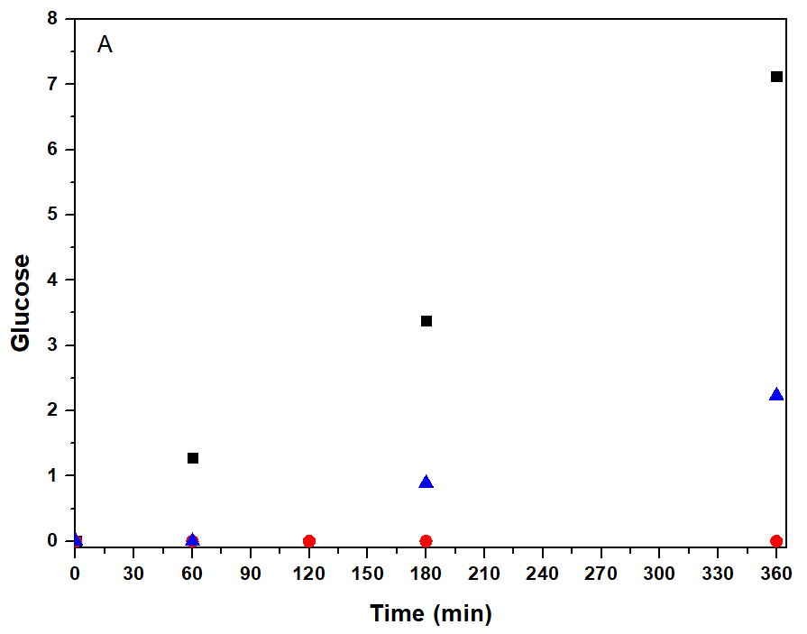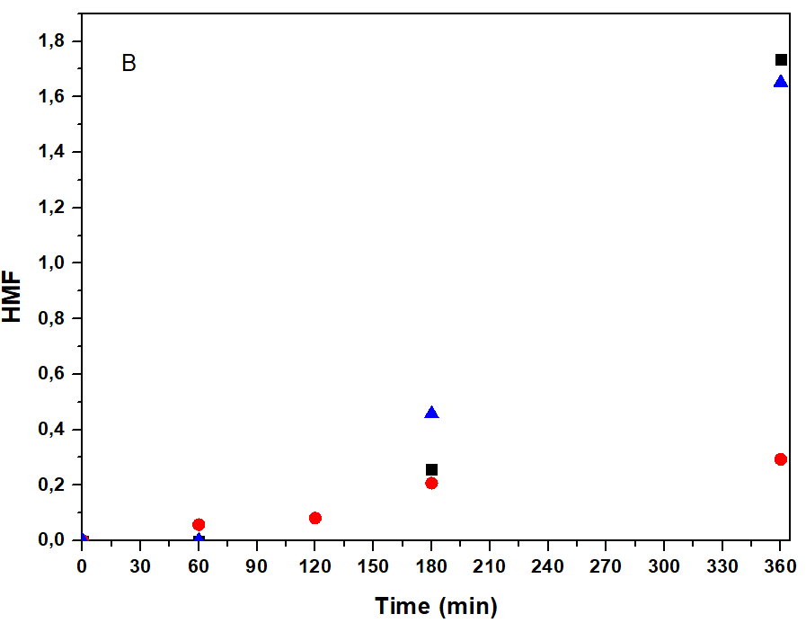
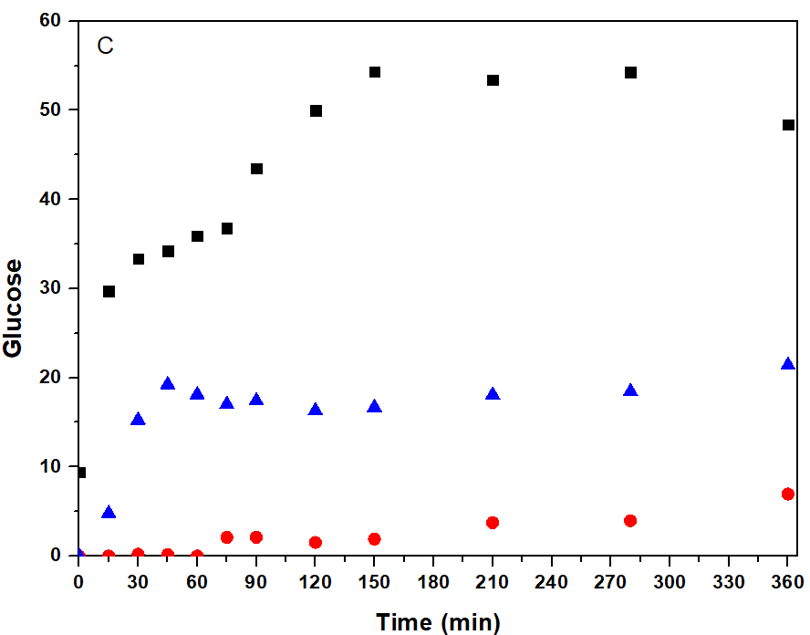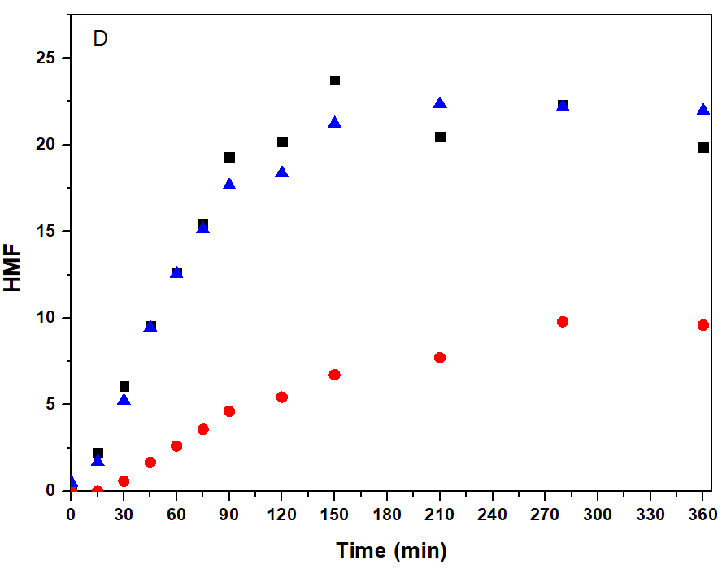
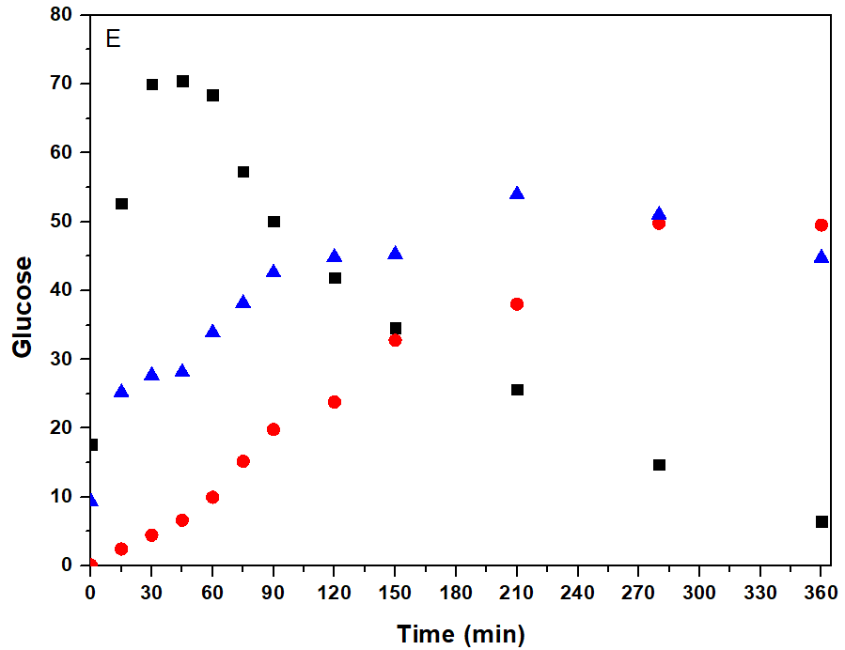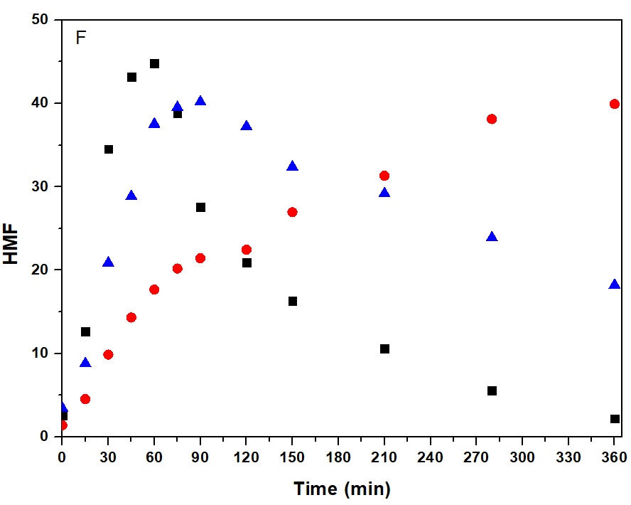
Figure 1: Yields for glucose and HMF (g/Kg) obtained used catalysts PNb (black rectangles), HNb (red circles), and HPNb (blue triangle) at temperatures of 150°C (A and B), 175°C (C and D) and 200°C (E and F).

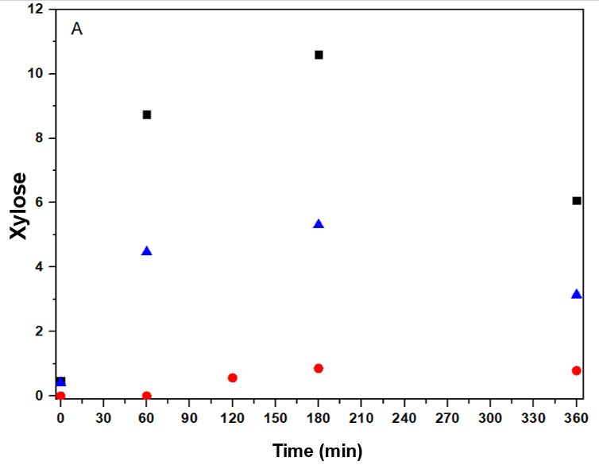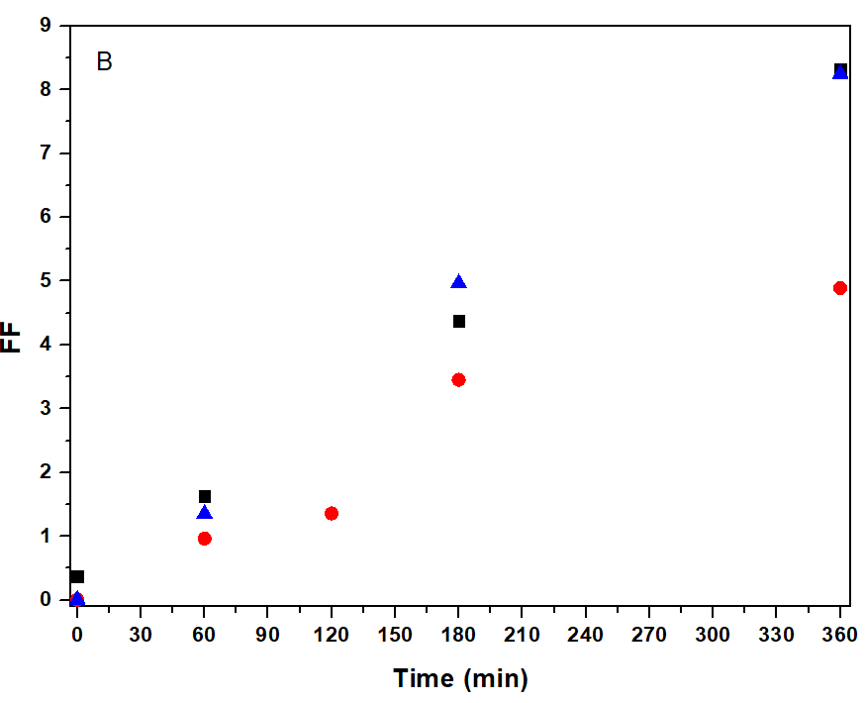
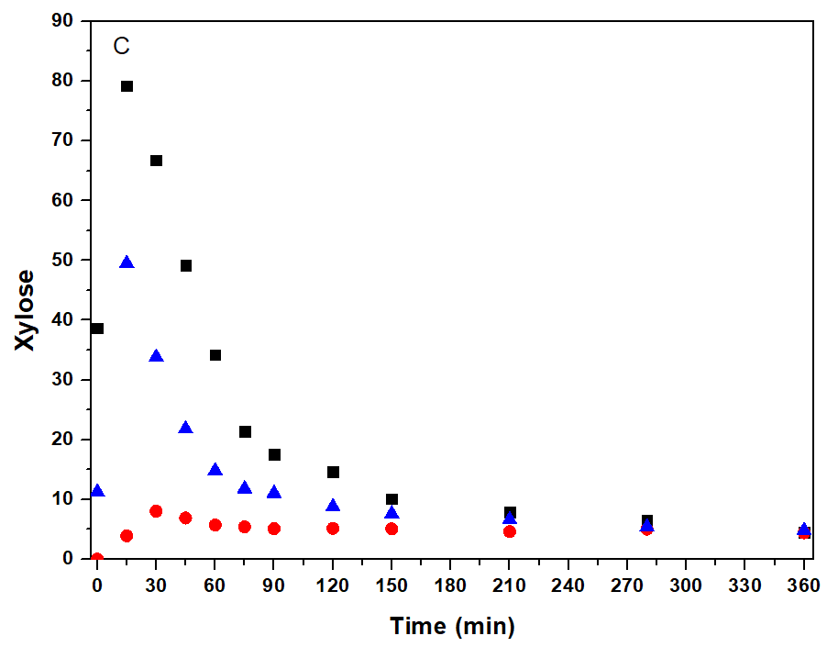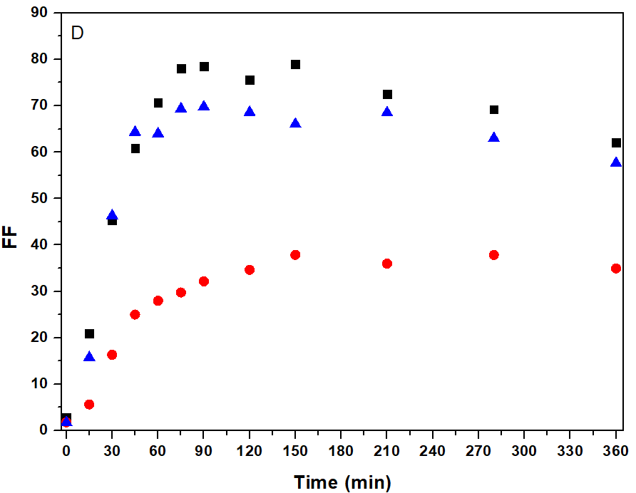
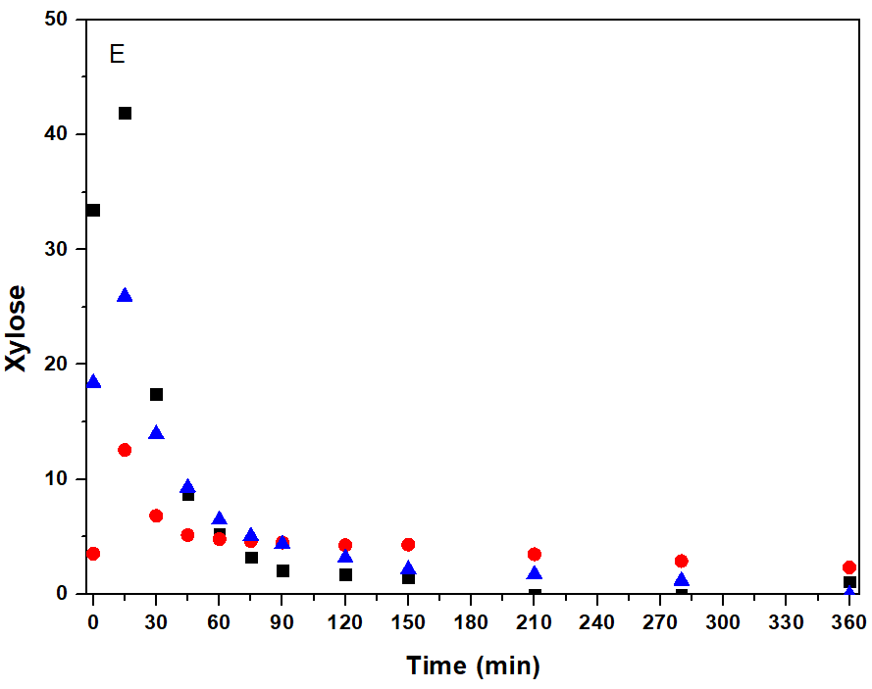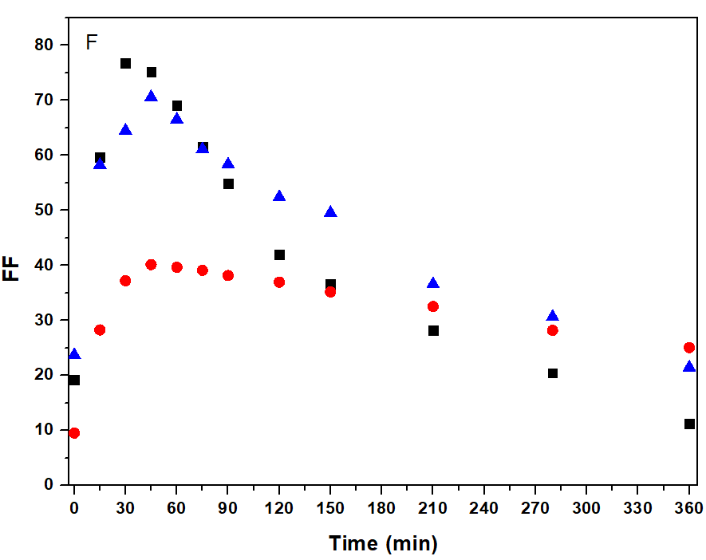
Figure 2: Yields for xylose and FF (g/Kg) obtained used catalysts PNb (black rectangles), HNb (red circles), and HPNb (blue triangle) at temperatures of 150°C (A and B), 175°C (C and D) and 200°C (E and F).

When comparing the theoretical yields obtained in this study with the literature data presented by Catrinck et al. (2020), Table 1, regarding the production of HMF and FF from sugarcane bagasse in aqueous media using niobium-based catalysts, it was possible to obtain higher yields of the products when using holocellulose. In addition, these results were achieved using a smaller amount of catalyst and shorter reaction times. This superior performance can be attributed to the use of higher conditions for temperature and feedstock content in this work. Given this, the strategy of producing HMF and FF using niobium-based catalysts from holocellulose shows potential for becoming a biorefinery technology. However, we stress the need for further work to assess the economic viability of this process.

Table 1: Yield of HMF and FF from different raw materials.
RM | RM content (%) | Reaction condition | Cat | RM/Cat | Theoretical yield |  | References
 |  |  |  |  | HMF (%) | FF (%)
SCB | 2 | 300 min  150°C | HNb | 1:1 | 1.0 | 19.1 | (Catrinck et al., 2020)
 |  | 300 min  150 °C | Pnb | 1:1 | 1.3 | 26.2
Holocelulose | 6 | 360/45 min  200 °C | HNb | 3:1 | 6.8 | 21.2 | This work
 |  | 60/30 min  200 °C | PNb | 3:1 | 7.6 | 43.8
 |  | 90/45 min  200 °C | HPNb | 3:1 | 6.8 | 40.2
RM = Raw materials Cat = catalyst SCB = sugarcane bagasse
  - Conclusions
The experimental results made it possible to evaluate the catalytic activity of the PNb, HNb, and HPNb catalysts for simultaneously converting holocellulose into HMF and FF. This evaluation was based on the yield of glucose, xylose, HMF, and FF as a function of time and temperature. In addition, it was shown that the maximum yield of HMF and FF occurs under different conditions for each catalyst. PNb was the catalyst that showed superior catalytic activity compared to the other catalysts when milder times and temperatures were considered. On the other hand, the use of HPNb did not reveal results that justified its use. This work provides valuable insights that could guide the development of new technologies for the efficient production of HMF and FF, opening up promising new avenues in high-value-added compound production.
Acknowledgments
The authors thank the Brazilian Research Agencies (CAPES) [grant no. 88887.505928/2020-00], São Paulo State Research Foundation (FAPESP) [grant no. 2015/20630-4] for the financial support and to Companhia Brasileira de Metais e Metalurgia (CBMM) for supplying the catalysts used in this work.

References
Batamack, P., Vincent, R., & Fraissard, J. (1996). Niobium oxide acidity studied by proton broad-line NMR at 4 K and MAS NMR at room temperature. Catalysis letters, 36, 81-86. https://doi.org/10.1007/BF00807209
Bozell, J. J., & Petersen, G. R. (2010). Technology development for the production of biobased products from biorefinery carbohydrates—the US Department of Energy’s “Top 10” revisited. Green chemistry, 12(4), 539-554. https://doi.org/10.1039/B922014C
Catrinck, M. N., Barbosa, P. S., Helder Filho, R. O., Monteiro, R. S., Barbosa, M. H., Ribas, R. M., & Teófilo, R. F. (2020). One-step process to produce furfural from sugarcane bagasse over niobium-based solid acid catalysts in a water medium. Fuel Processing Technology, 207, 106482. https://doi.org/10.1016/j.fuproc.2020.106482
Catrinck, M. N., Ribeiro, E. S., Monteiro, R. S., Ribas, R. M., Barbosa, M. H., & Teófilo, R. F. (2017). Direct conversion of glucose to 5-hydroxymethylfurfural using a mixture of niobic acid and niobium phosphate as a solid acid catalyst. Fuel, 210, 67-74. https://doi.org/10.1016/j.fuel.2017.08.035
De Carvalho, E.G.L., Rodrigues, F.D.A., Monteiro, R.S., Ribas, R.M., Da Silva, M.J., 2018. Experimental design and economic analysis of 5-hydroxymethylfurfural synthesis from fructose in acetone-water system using niobium phosphate as catalyst, Biomass Conv. Bioref. 8 (3) 635–646.https://doi.org/10.1007/s13399-018-0319-5
De Carvalho, R.S., Rodrigues, F.Á, Monteiro, R.S., Da Silva Faria, W.L., (2019).Optimization of furfural synthesis from xylose using niobic acid and niobium phosphate as catalysts. Waste and Biomass Valorization, 10, 2673-2680.https://doi.org/10.1007/s12649-018-0272-3
De Jesus Junior, M. M., Fernandes, S. A., Borges, E., Baeta, B. E. L., & de Ávila Rodrigues, F. (2022). Kinetic study of the conversion of glucose to 5-hydroxymethylfurfural using niobium phosphate. Molecular Catalysis, 518, 112079. https://doi.org/10.1016/j.mcat.2021.112079
Fan, G., Chen, Y., Lu, Y., Cheng, Q., Chai, B., & Song, G. (2023). Co-production of 5-hydroxymethyl furfural and furfural from holocellulose over UiO-66-derived acid-base catalysts. Chemical Engineering Science, 276, 118768. https://doi.org/10.1016/j.ces.2023.118768
Fan, G., Wang, Y., Hu, Z., Yan, J., Li, J., & Song, G. (2018). Synthesis of 5-hydroxymethyl furfural from cellulose via a two-step process in polar aprotic solvent. Carbohydrate polymers, 200, 529-535. https://doi.org/10.1016/j.carbpol.2018.08.043
Fan, X., Ren, M., Zhou, C., Kong, F., Hua, C., Fakayode, O. A., ... & Wang, X. (2024). Total utilization of lignocellulosic biomass with xylooligosaccharides production priority: A review. Biomass and Bioenergy, 181, 107038. https://doi.org/10.1016/j.biombioe.2023.107038
Fernández-Coppel, I. A., Barbosa-Evaristo, A., Corrêa-Guimarães, A., Martín-Gil, J., Navas-Gracia, L. M., & Martín-Ramos, P. (2018). Life cycle analysis of macauba palm cultivation: a promising crop for biofuel production. Industrial Crops and Products, 125, 556-566. https://doi.org/10.1016/j.indcrop.2018.09.036
Lu, Y., He, Q., Peng, Q., Chen, W., Cheng, Q., Song, G., & Fan, G. (2021). Directional synthesis of furfural compounds from holocellulose catalyzed by sulfamic acid. Cellulose, 28, 8343-8354. https://doi.org/10.1007/s10570-021-04070-8
Mika, L. T., Cséfalvay, E., & Németh, Á. (2018). Catalytic conversion of carbohydrates to initial platform chemicals: chemistry and sustainability. Chemical reviews, 118(2), 505-613. https://doi.org/10.1021/acs.chemrev.7b00395
Nakajima, K., Baba, Y., Noma, R., Kitano, M., Kondo, J. N., Hayashi, S., & Hara, M. (2011). Nb2O5· nH2O as a heterogeneous catalyst with water-tolerant Lewis acid sites. Journal of the American Chemical Society, 133(12), 4224-4227. https://doi.org/10.1021/ja110482r
Perez, G. P., Mukherjee, A., & Dumont, M. J. (2019). Insights into HMF catalysis. Journal of Industrial and Engineering Chemistry, 70, 1-34. https://doi.org/10.1016/j.jiec.2018.10.002
Rodriguez-Alvarez, M. J., Garcia-Garrido, S. E., Perrone, S., García-Álvarez, J., & Capriati, V. (2023). Deep eutectic solvents and heterogeneous catalysis with metallic nanoparticles: A powerful partnership in sustainable synthesis. Current Opinion in Green and Sustainable Chemistry, 39, 100723. https://doi.org/10.1016/j.cogsc.2022.100723
Wataniyakul, P., Boonnoun, P., Quitain, A. T., Sasaki, M., Kida, T., Laosiripojana, N., & Shotipruk, A. (2018). Preparation of hydrothermal carbon as catalyst support for conversion of biomass to 5-hydroxymethylfurfural. Catalysis Communications, 104, 41-47. https://doi.org/10.1016/j.catcom.2017.10.014
You, L., Liu, T., Liu, D., & Zhao, X. (2023). Efficient conversion of glucose to 5-hydroxymethylfurfural by synergetic catalysis of enzymes and chemical catalysts towards potential large-scale continuous operation. Chemical Engineering Journal, 459, 141552. https://doi.org/10.1016/j.cej.2023.141552
Zhang, W., Zhang, B., Lei, F., Li, P., & Jiang, J. (2022). Coproduction xylo-oligosaccharides with low degree of polymerization and glucose from sugarcane bagasse by non-isothermal subcritical carbon dioxide assisted seawater autohydrolysis. Bioresource Technology, 349, 126866. https://doi.org/10.1016/j.biortech. 2022.126866
Zhang, Y., Wang, J., Li, X., Liu, X., Xia, Y., Hu, B., ... & Wang, Y. (2015). Direct conversion of biomass-derived carbohydrates to 5-hydroxymethylfurural over water-tolerant niobium-based catalysts. Fuel, 139, 301-307. https://doi.org/10.1016/j.fuel.2014.08.047

